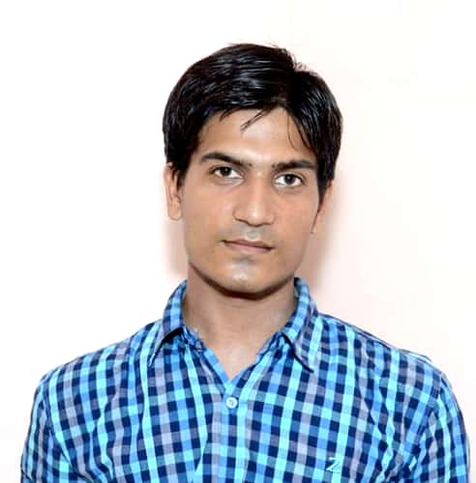
JECRC
Affix and Attest
passport
size photograph
JAIPUR

INDIVIDUAL TECHNICIAN DATA SHEET
Name of the Technical staff member | : | Hemant naiwal
Present Designation | : | Sr. Lab Instructor
Email Id: :hemant.me@jecrc.ac.in
Contact Details :8946969555

I. Particulars of Educational Qualification: (only completed)

Category | Name of the Degree | Specialization | Year of Passing | Name of the College | Name of the University
ITI | ITI | Fitter | 2006 | Agrsain ITI,hindon city | BTER
Diploma | Diploma | Mechanical | 2012 | JRN rajathan vidypeeth, Udaipur | JRNV
UG | B. A | Arts | 2014 |  | RU
PG | M.A | History | 2016 |  | RU

II. Academic Experience : 10 Year

III. Industrial Experience : 2 YEAR

